Experiment 1: Interactive Diagram of a Basic Cellular System

Aim
To create an interactive diagram of a basic cellular system using Figma, illustrating the major components such as the Mobile Station, Base Station, Cell/Coverage Area, Radio Link, and Core Network, and showing how they communicate with each other.

Algorithm
- Open Figma and create a new design file.
- Create a main frame for the cellular system diagram.
- Add the Mobile Station representing the user's mobile phone.
- Add the Base Station representing the cell tower.
- Add the Cell/Coverage Area around the base station.
- Add the Radio Link between the mobile station and base station.
- Add the Core Network connected to the base station.
- Use arrows/connectors to represent the flow of communication.
- Create interactive components for each major element.
- Add On Click interactions so that selecting a component displays information about its function.
- Use Prototype mode to connect the different states.
- Preview the prototype and verify that all interactions work correctly.
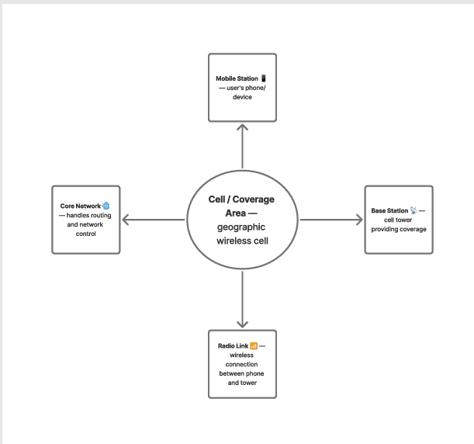

Result
The interactive basic cellular system diagram was successfully designed in Figma. It clearly represents the Mobile Station, Base Station, Cell/Coverage Area, Radio Link, and Core Network, along with their communication relationships. Interactive elements were added to provide information about each component when selected.

Experiment 2: Mobile Station User Interface Prototype

Aim
To design a user interface prototype for a mobile station using Figma, focusing on connectivity, accessibility, and user convenience.

Algorithm
- Open Figma and create a new design file.
- Create a mobile phone frame suitable for a smartphone screen.
- Design the main Home/Dashboard screen.
- Add a Network Status section showing the connected network and signal strength.
- Add connectivity options such as:
  - Wi-Fi
  - Mobile Data
  - Bluetooth
  - Location
- Add navigation options such as Home, Contacts, and Settings.
- Create separate screens for Wi-Fi, Mobile Data, Bluetooth, and Settings.
- Use buttons and icons to make the interface simple and convenient.
- Switch to Prototype mode in Figma.
- Add On Click → Navigate to interactions between the screens.
- Add suitable transitions such as Smart Animate.
- Preview the prototype and test all navigation buttons.
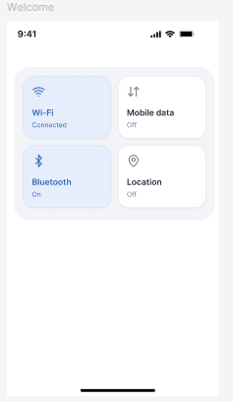

Result
The mobile station user interface prototype was successfully designed in Figma. The prototype provides convenient access to Wi-Fi, mobile data, Bluetooth, location, network status, contacts, and settings. Interactive navigation between screens was implemented to provide a simple and user-friendly connectivity experience.

Experiment 3: Network Switching Subsystem Flowchart

Aim
To develop a flowchart in Figma depicting the operation of the Network Switching Subsystem (NSS) in a mobile cellular system, showing the process of call initiation, authentication, switching, routing, and call termination.

Algorithm
- Open Figma and create a new design file.
- Create a flowchart frame with the title “Network Switching Subsystem in Mobile Cellular System.”
- Start the flowchart with the Mobile Station (MS).
- Show the Base Station Subsystem (BSS) receiving the call request from the mobile station.
- Send the request to the Mobile Switching Centre (MSC).
- The MSC checks the subscriber information using the Home Location Register (HLR).
- Use the Authentication Centre (AuC) to authenticate the subscriber.
- Use the Visitor Location Register (VLR) to obtain temporary subscriber/location information.
- If authentication is successful, the MSC establishes and routes the call.
- If the destination is another network, route the call through the appropriate Gateway MSC (GMSC).
- Establish the connection between the calling and receiving users.
- During the call, the MSC manages switching and mobility.
- When the call ends, release the allocated network resources.
- Add arrows and decision symbols in Figma to clearly show the flow.
- Use Prototype mode to make important flowchart elements interactive if required.
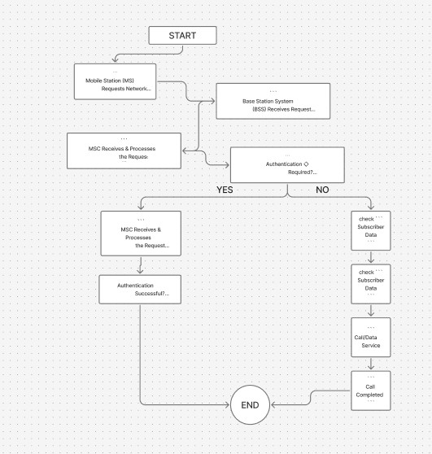

Result
The Network Switching Subsystem flowchart was successfully developed in Figma. The flowchart represents the complete operation of the NSS, including call initiation, subscriber authentication, HLR/VLR lookup, switching through the MSC, call routing, connection establishment, and resource release. It provides a clear visual representation of how a cellular network handles a mobile call.

Experiment 4 : Visual Representation of Mobile Network Protocol Stacks in Figma

Aim
To create a visual representation in Figma highlighting the key elements and layers of mobile network protocol stacks and showing how communication takes place between the mobile device and the network.

Algorithm
- Open Figma and create a new design file.
- Create a large frame titled “Mobile Network Protocol Stack”.
- Divide the frame into different protocol layers.
- Add the Application Layer at the top for services such as voice, video, messaging, and Internet applications.
- Add the Transport Layer containing protocols such as TCP/UDP.
- Add the Network Layer containing IP for packet routing.
- Add the Radio/Link Layer for wireless communication between the mobile device and base station.
- Add the Physical Layer representing the radio signal and transmission medium.
- On one side, create a Mobile Station (MS) and on the other side create the Mobile Network/Core Network.
- Connect the layers using arrows to show the flow of data.
- Use different shapes and icons to distinguish each protocol layer.
- Open Prototype mode and add interactions such as clicking a layer to display its function.
- Preview the design and verify that all layers and connections are clearly visible.
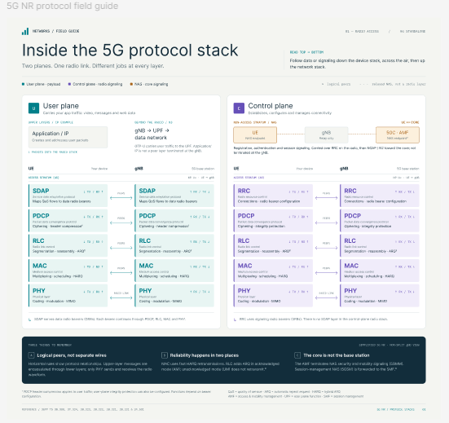

Result
The Mobile Network Protocol Stack was successfully represented in Figma. The visual design clearly shows the different protocol layers, their key functions, and the communication flow between the mobile station, base station, and core network.

Experiment 5: Mobile Application Wireframe with Localization Features Using Figma

Aim
To design a mobile application wireframe in Figma that incorporates localization features such as language selection, location access, regional settings, and localized content for a better user experience.

Algorithm
- Open Figma and create a new design file.
- Create a mobile-sized frame, such as iPhone/Android screen.
- Design the Welcome/Home Screen with the application name, location, and main options.
- Add a Language Selection option with languages such as English, Tamil, Hindi, and Telugu.
- Add a Location Selection option to allow the user to select their city or region.
- Add a GPS/Current Location option for detecting the user's current location.
- Create a Regional Settings screen containing:
  - Language
  - Country/Region
  - Time Zone
  - Date Format
  - Currency
- Create separate screens for Home, Location, Language, and Settings.
- Add buttons, icons, dropdowns, and navigation elements using Figma shapes and components.
- Open the Prototype tab in Figma.
- Connect buttons using On Click → Navigate to.
- Connect the language button to the Language Selection screen.
- Connect the location button to the Location Selection screen.
- Connect the Settings button to the Regional Settings screen.
- Preview the prototype and verify that all localization features work correctly.\
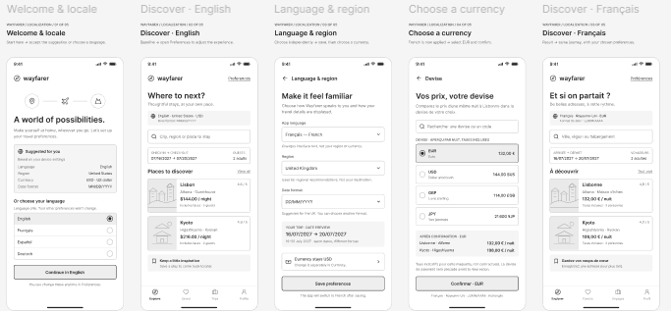

Result
A mobile application wireframe with localization features was successfully designed in Figma. The wireframe provides language selection, location detection, regional settings, and easy navigation, allowing the application to adapt to users from different regions and languages.

Experiment 6: Mobile Network Handoff Simulation Using Figma

Aim
To use Figma to simulate and visualize the handoff process in a mobile network, showing how an active mobile connection is transferred from one cell/base station to another while the user moves.

Algorithm
- Open Figma and create a new design file.
- Create a frame titled “Mobile Network Handoff Simulation.”
- Draw two adjacent coverage areas:
  - Cell 1 – Base Station A
  - Cell 2 – Base Station B
- Place a Mobile Station (MS) inside Cell 1.
- Draw a communication link between the mobile device and Base Station A.
- Show the mobile device moving toward Cell 2 using arrows.
- Add a Signal Strength indicator that decreases from Base Station A as the device moves away.
- Show Base Station B detecting a stronger signal.
- Add a decision point: “Is Target Cell Signal Stronger?”
- If No, continue communication with Base Station A.
- If Yes, initiate the Handoff Request.
- Transfer the connection from Base Station A to Base Station B.
- Show the mobile device connected to Base Station B.
- Use Figma Prototype mode to connect the screens using On Click → Navigate to.
- Use Smart Animate to create a simple movement effect for the mobile device.
- Preview the prototype and verify the complete handoff process.
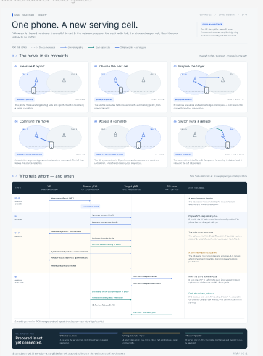

Result
The mobile network handoff process was successfully simulated in Figma. The prototype visually demonstrates how an active mobile connection is transferred from Base Station A to Base Station B when the user moves between coverage areas, while maintaining continuous communication.

Experiment: Cellular System Performance Dashboard Using Figma

Aim
To develop a dashboard prototype in Figma that displays important performance criteria of a cellular system, such as network availability, signal strength, call success rate, dropped calls, data throughput, latency, and active users.

Algorithm
- Open Figma and create a new design file.
- Create a desktop frame for the Cellular Network Performance Dashboard.
- Add a header containing:
  - Dashboard title
  - Network name
  - Date and time
  - Network status
- Create KPI cards for important performance parameters.
- Add a Network Availability card showing the percentage of network availability.
- Add a Call Success Rate card showing successful calls.
- Add a Dropped Call Rate card.
- Add a Data Throughput card showing the average data speed.
- Add a Latency card showing network response time.
- Add an Active Users card showing the number of connected users.
- Preview the dashboard and verify that all performance criteria are clearly displayed.
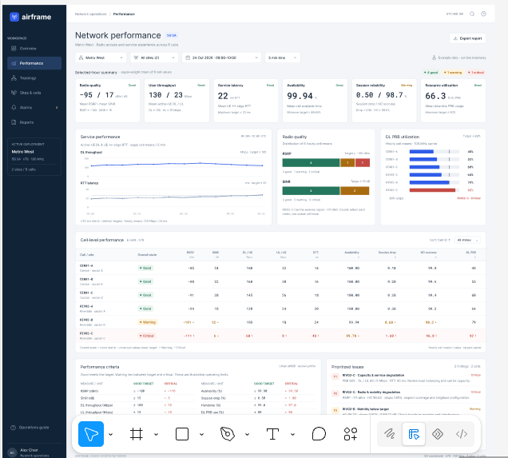

Result
A cellular system performance dashboard prototype was successfully designed in Figma. The dashboard visually displays important performance criteria including network availability, call success rate, dropped calls, throughput, latency, signal strength, active users, and cell status, allowing network performance to be monitored easily.

